Saint Leo University Survey on a Student Linux Distro

Chase S. Franse

Saint Leo University

Abstract

For this project we created a survey that was distributed to students all around Saint Leo University and a few other people outside Saint Leo to ensure breadth of response. This survey was created to provide feedback for a theoretical project that is planned take place in the Spring 2021 semester at Saint Leo University – the creation of a custom, student-oriented Linux distribution. The survey asked participants about features – useful and unnecessary – as well as broaching the topic of beta testing and which survey participants would like to beta test when the time comes.

Keywords: Linux, Student, Survey

# Introduction

My team and I decided we should do a little groundwork on the design and proposal that will become our capstone project in the Spring 2021 semester here at Saint Leo University. Our project to create a Linux distribution designed for students – specifically Computer Science/Cybersecurity students but will be available for anyone who wants to use it. This “Linux Distribution” is just a fancy way of saying that we are making a custom version of the Linux operating system (OS) to suit our needs. Linux is an open-source OS which means that, when this project is complete, it will be free to download and use for everyone! Our team decided to create a survey through *SurveyMonkey* to poll and ask students of all kinds what tools and features they liked or disliked, what graphical desktop environment did they prefer, and even if they would be willing to beta test our system when it is ready for that.

## The Survey1

The team crafted and included nine different questions into a survey that we thought would prove to be beneficial by outlining what tools and features college students would actually like to have. In particular, there are three questions that were specifically designed to provide us with the most information possible for creating the best system we can.

The first of these vitally important questions was about features. A list of pre-planned features, that was put together by the team was provided and the survey participants simply needed to select the features/programs that they did *not* believe were necessary.

The results varied, and some even seemed strange but, according to the subject pool, some of the tools that were the most unnecessary include:

* WINE
* MLA, APA, & Chicago Citation Generator
* Dual Boot Compatibility
* VS Code/ATOM Code Editors

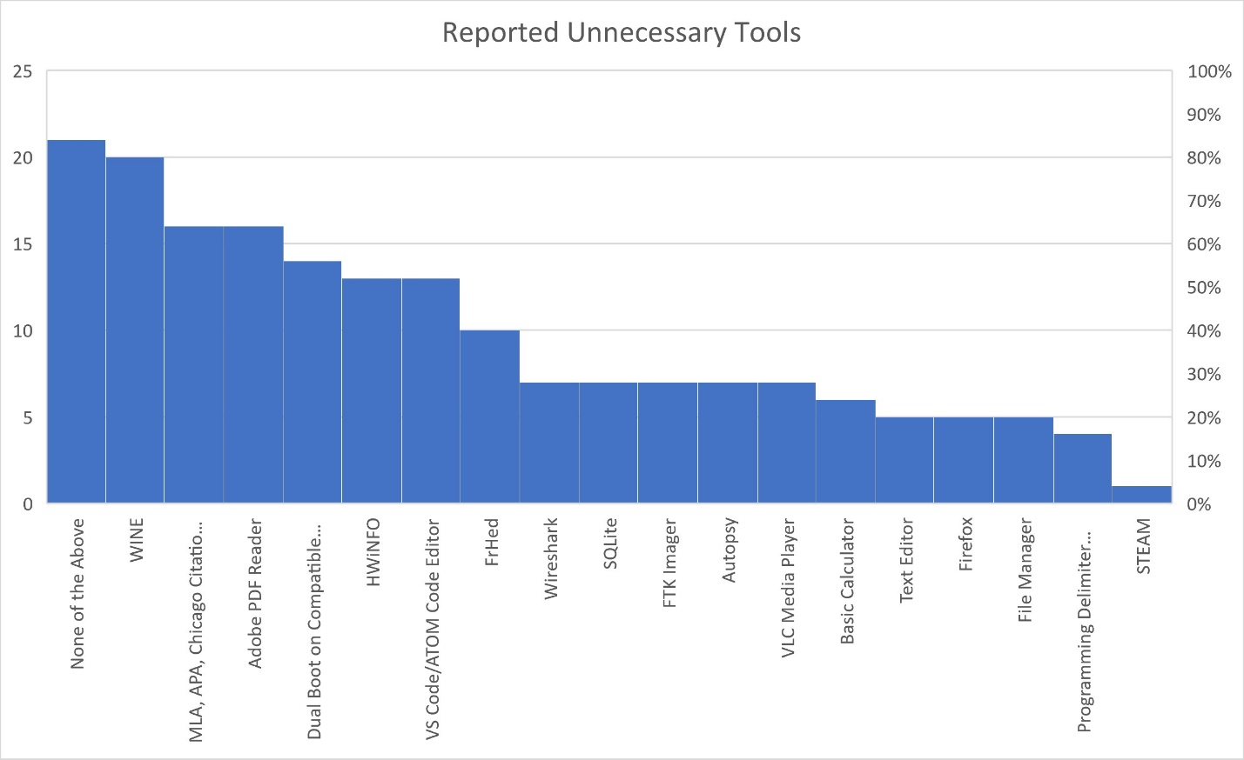

WINE is a tool that allows the running of Windows processes on non-Windows systems. This means that nearly any program or tool that one might want to use that is originally designed and used on Windows, can be installed and run properly on whatever Linux kernel we use as a base for our distribution.

The MLA, APA, & Chicago Citation Generator is a custom program that we have planned to include in this student-centered Linux distribution. It is planned to be an executable Java program that would allow the user to choose a citation style (MLA, APA, or Chicago), provide source information, and return a completed citation in the chosen style.

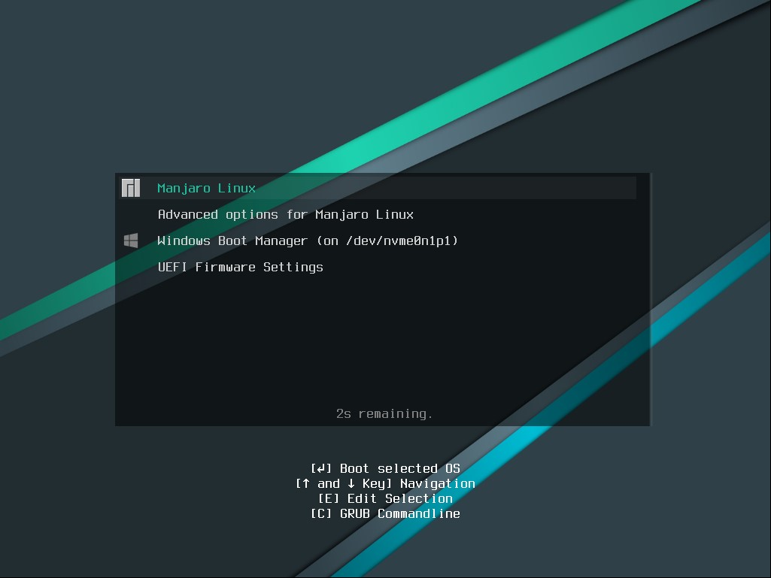Dual boot compatibility is a feature that would allow users to install this student-focused Linux distribution *alongside* whatever operating system they already have. This would allow for users to take advantage of the pre-installed toolset, as well as the large set of potential tools that Linux is able to take advantage of, while being able to keep and fully use whatever operating system they already have.

VS Code/ATOM Code Editors are code editors that have integrated development environment support for most programming languages including but not limited to: Java, C++, Python, JavaScript, etc.

These results were a little surprising, seeing how approximately 39% of the total survey participants were either Computer Science or Cybersecurity majors. Features and tools like WINE, Dual Boot Compatibility, and VS Code may not be widely known, understood, or seemingly important to most people, but the Computer Science and Cybersecurity majors should have knowledge of just how important these things are to new Linux users. In specific, 30% of all Computer Science and Cybersecurity majors that took the survey said that both WINE and VS/ATOM Code Editors were unnecessary!

The second extremely important question that was asked in our survey was about the look and feel of the operating system. This question was actually broken into two - first we asked which desktop environment people were most familiar with, and then we asked how they would like our Linux distribution to be loosely modeled after.

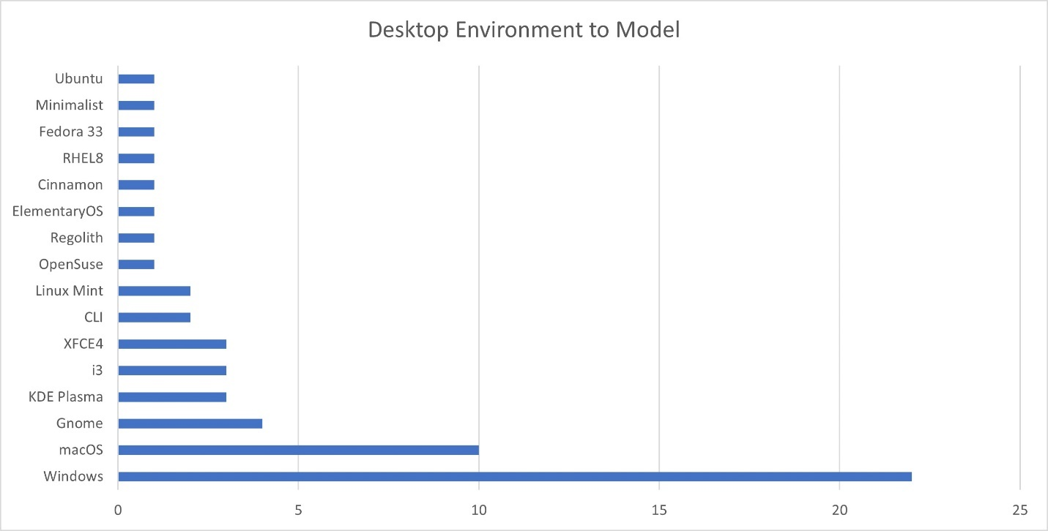

It can be difficult to accurately complete coursework if you are entirely unfamiliar with the computer system you are working on. To avoid/counteract that potential stumbling block, we crafted a question that would let us know exactly what our potential users are already comfortable with, and what they might like to see in the future.

According to *Statista*, as of July 2020 approximately 78% of computers worldwide run the Windows operating system. As such, it comes as no surprise that 47% of the survey participants chose Windows for both the environment they are most familiar with, as well as the desktop environment to loosely model our team’s new Linux distribution after. All this means is that the survey takers would prefer the default design of our Linux distribution to have elements more like those of the Windows operating system - similar to the default design of Manjaro Linux (shown above, on the right) – as opposed to the design of macOS or other forms of Linux like Ubuntu (shown left). While it is true that the default design of the graphical user interface (GUI) has little or no impact on the functionality of the operating system and is easy to change or modify for the more advanced Linux users, our team wants to make this distribution easy to use for as many potential users as we can.

The third crucial question that we asked in our survey was to determine how many, if any, of our survey participants would like to become potential beta testers for our Linux distribution, should we need them when the project reaches that stage.

Our team firmly believes that beta testers would help us to catch the greatest number of bugs and flaws in the system, *before* the general release that is planned for the end of the Spring 2021 semester. These beta testers would also be able to provide feedback on what types of *additional* programs and features would make our Linux distribution even more effective for students of all kinds.

For most people, Linux is seen as something of a two-headed snake; it is an interesting topic, but also dangerous for their systems and highly misunderstood. Because of this, we did not expect to receive many survey participants to agree to become potential beta testers - we were, however, shocked by the results we got back. From a poll group of 60 participants, **35** of them (58%) showed interest in becoming potential beta testers! While we won’t ask them all to beta test our Linux distribution, we plan to follow up with and request many of them to test the project for us - when the time comes.

## Conclusion

Through this survey my team and I laid the groundwork on the design that will transform into our capstone project in the Spring 2021 semester here at Saint Leo University. This capstone project will be to design and create a Linux distribution designed for students – namely Computer Science/Cybersecurity students but will be readily available for any student that wants to give it a shot! It was through the power of *SurveyMonkey* that we were able to identify what tools and features students like and dislike – information that can only make our project better in the long-run.

# Figures

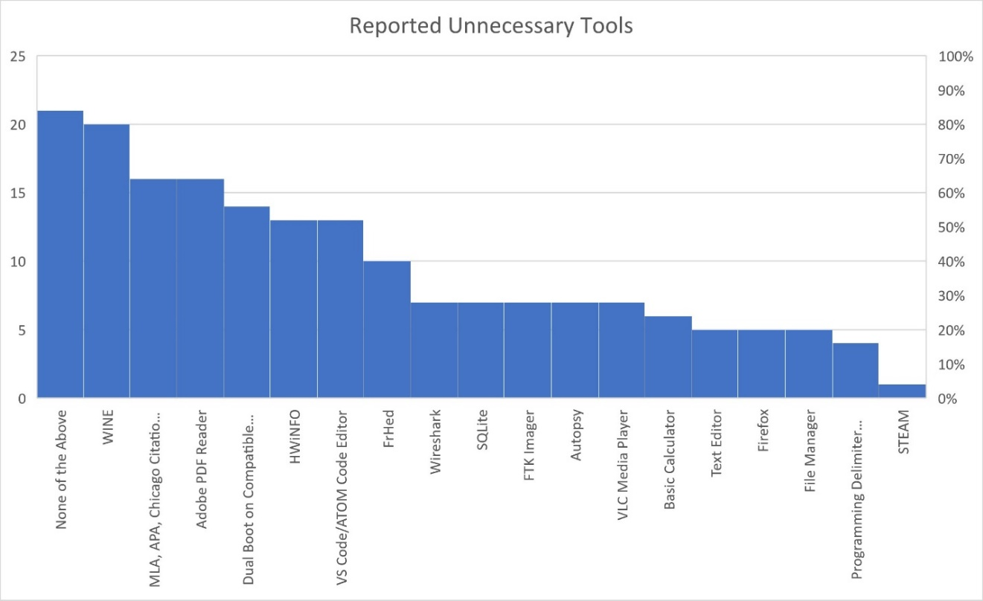

# References

*What Is Wine?* www.winehq.org/.

*Manjaro – Enjoy the Simplicity*. manjaro.org/.

Liu, S. (2020, November 26). *Desktop OS market share 2020*. Statista. https://www.statista.com/statistics/218089/global-market-share-of-windows-7/.